Traditional College and Degree Alternatives
Shifting the Paradigms

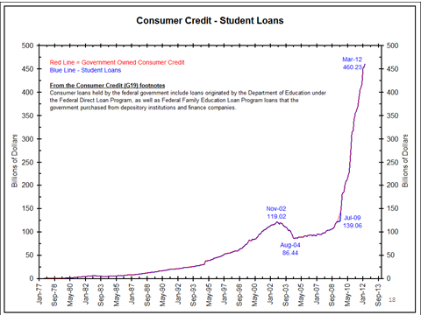
What’s happening to make college costs increase so much more than income? Why are student loans spiraling sky-high? Is college really the next economic “bubble”?

But on the other hand . . . isn’t the “college experience” worth whatever the cost might be? Don’t you really need that degree? What about that extra million dollars college is supposed to earn you over a lifetime?

It’s time to shake up some presuppositions.

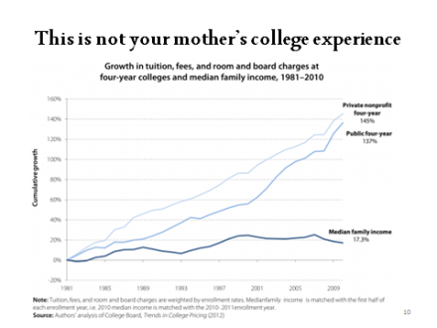
This three-hour seminar will explore the reasons people assume that they ought to “go to college,” why “going to college” has grown to be a bigger and bigger problem, creative alternatives to all the best that a college has to offer, and fully accredited alternative ways—for those who decide it’s worth the investment of time and money—to get a nontraditional college degree, at about a tenth of the cost of a traditional college degree. This workshop, parts of which were first presented over ten years ago, has been expanded and updated to include the consideration of the current college debt crisis that is

bringing an unprecedented number of bright and capable young people into

the heavy burden of indentured servitude.

* Thank you so much for presenting sucn an informative and NEEDED message! I will certainly be referring friends to your site and FB page to hear you speak in the future. –Patti

* The seminar was great! I knew the current college system was broken, but now know why and am informed as to other options! –Jan

* It was helpful to me to start thinking “outside the college box.” –Cindy

* Thank you so much for all the great information! –Sam

. * FABULOUS information!!! –Heidi

Though she earned her master’s degree in education traditionally (a long time

ago), Rebecca Davis has become passionate about helping people, for the glory

of God, find alternatives to traditional college. You can learn more about her at

her website, www.heresthejoy.com. We also have a “Traditional College and

Degree Alternatives” Facebook group that you’re welcome to join, where we ask questions and share information with each other, about college costs, college debt,

and creative alternatives to traditional college.

Know anybody with $20,000 of college debt? How about $50,000? Or $100,000?

It’s time to shake up some presuppositions.

DATE: ____________________ LOCATION: ____________________________

COST: $5.00 per person ____________________________

